status_life_exp = life_expectancy.groupby(by=['Status']).mean().reset_index().sort_values('winz_Life_expectancy',ascending=False).reset_index(drop=True)

plt.figure(figsize=(20,10))

fig = px.bar(status_life_exp, x='Status', y='winz_Life_expectancy',color='winz_Life_expectancy')

fig.update_layout(

title="Life expectancy according to status",

xaxis_title="Status",

yaxis_title="Average Life Expectancy",

font=dict(

family="Courier New",

size=16,

color="black"

)

)

fig.show()

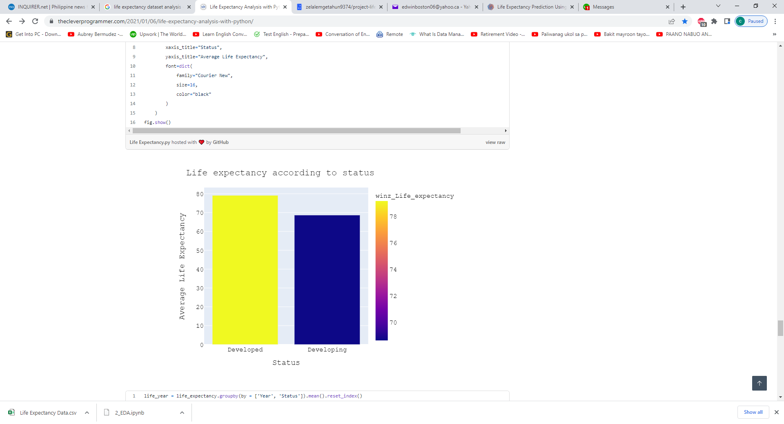

life_year = life_expectancy.groupby(by = ['Year', 'Status']).mean().reset_index()

Developed = life_year.loc[life_year['Status'] == 'Developed',:]

Developing = life_year.loc[life_year['Status'] == 'Developing',:]

fig1 = go.Figure()

for template in ["plotly_dark"]:

fig1.add_trace(go.Scatter(x=Developing['Year'], y=Developing['winz_Life_expectancy'],

mode='lines',

name='Developing',

marker_color='#f075c2'))

fig1.add_trace(go.Scatter(x=Developed['Year'], y=Developed['winz_Life_expectancy'],

mode='lines',

name='Developed',

marker_color='#28d2c2'))

fig1.update_layout(

height=500,

xaxis_title="Years",

yaxis_title='Life expectancy in age',

title_text='Average Life expectancy of Developing and Developed countries over the years',

template=template)

fig1.show()

